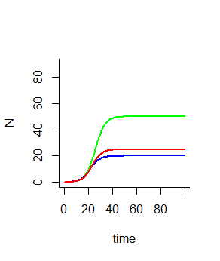Figure for 2a (with 2b lines as well)

***Legend: Data Sets***

Red= Sim.3 or K=25

Green=Sim.2 or K=50

Blue= Sim or K=20

Figure for 2b:

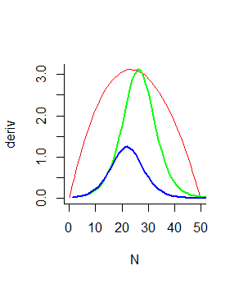

***Legend: Data Sets***

Red= Sim.3 or K=25

Green=Sim.2 or K=50

Blue= Sim or K=20

2c: The ideal population abundance is from 22-26. Additionally, K=50 is the best population capacity/ abundance of group with it peaking at 26 individuals.

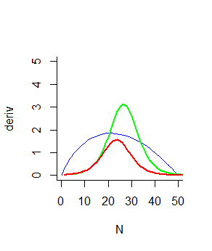Figures for 3 plotted with population against time and also deriv with K=50 and r=0.25 from last problem. I believe Species A has the highest abundance.

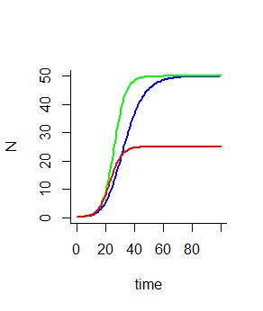

***Legend: Data Sets***

Red= species C

Green=species B

Blue= Species A